ish¿u ysñlï weúßKs $ All Rights Reserved

St. Peter's College

St. Peter's College

St. Peter's College

புனித பேதுரு கல்லூரி

புனித பேதுரு கல்லூரி

புனித பேதுரு கல்லூரி

புனித பேதுரு கல்லூரி

புனித பேதுரு கல்லூரி

புனித பேதுரு கல்லூரி

புனித பேதுரு கல்லூரி

புனித பேதுரு கல்லூரி

Ydka; mS;r úÿy,

Ydka; mS;r úÿy,

Ydka; mS;r úÿy,

Ydka; mS;r úÿy,

Ydka; mS;r úÿy,

Ydka; mS;r úÿy,

Ydka; mS;r úÿy,

Ydka; mS;r úÿy,

Ydka; mS;r úÿy,

Ydka; mS;r úÿy,

St. Peter's College

St. Peter's College

St. Peter's College

St. Peter's College

St. Peter's College

St. Peter's College

St. Peter's College

St. Peter's College

St. Peter's College

St. Peter's College

புனித பேதுரு கல்லூரி

புனித பேதுரு கல்லூரி

புனித பேதுரு கல்லூரி

புனித பேதுரு கல்லூரி

புனித பேதுரு கல்லூரி

புனித பேதுரு கல்லூரி

புனித பேதுரு கல்லூரி

புனித பேதுரு கல்லூரி

Ydka; mS;r úÿy,

Ydka; mS;r úÿy,

Ydka; mS;r úÿy,

Ydka; mS;r úÿy,

Ydka; mS;r úÿy,

Ydka; mS;r úÿy,

Ydka; mS;r úÿy,

Ydka; mS;r úÿy,

Ydka; mS;r úÿy,

Ydka; mS;r úÿy,

St. Peter's College

St. Peter's College

St. Peter's College

St. Peter's College

St. Peter's College

St. Peter's College

St. Peter's College

86

E

**I,II**

**YdÍßl wOHdmkh**

**Physical Education**

**meh 02**

**Two Hour**

**11 fY%aKsh – m<uq jdr we.hsu - 2023**

***Grade 11 – First Term Examination - 2023***

Ydka; mS;r úÿy, - fld<U 04

புனித பேதுரு கல்லூரி, கொழும்பு 4

***St. Peter's College - Colombo 04***



Name: ………………………………………………. Class: …………… Index No: ………….

* **Answer all the questions.**
* **Underline the most suitable answer.**

01. A biomechanical principles that help to maintain posture is,

i. Flexibility ii. Centre of gravity

iii. Endurance iv. Energy

02. When the base of an object is larger, its balance,

i. Increases ii. Decreases

iii. Does not change iv. Increases and then decreases

03. A correct feature of lifting and lowering a weight in correct posture is,

i. Keeping the object as close to the body.

ii. Keeping the object far away from the body.

iii. Keeping the legs as close as possible.

iv. Bending the legs forward without bending at knees.

04. The answer in which only the outdoor activities that may give us experience are included is,

i. Exploring jungle , inter house sport meet

ii. Organized hikes , climbing hills

iii. March past , climbing hills

iv. Cooking food outdoor , march past

05. The factor that does not affect the distance of the height of the jump an athlete?

i. Landing point ii. Angle to take off

iii. Height of take off iv. Velocity of take off

* **Using the following information answer the question (6) and (7).**
* Athlete No 72 - Marathon , 10000m
* Athlete No 87 - 800m
* Athlete No 64 - 400m $×$ 4 , 400m
* Athlete No 52 - 100m , 200m , 400m

06. Select the athlete who use the crouch start technique for their events.

i. No 72 ii. No 64 iii. No 64 , 52 iv. No 72 , 87

07. The athlete / athletes who use standing start technique for their events,

i. No 72 ii. No 52 iii. No 64 , 52 iv. No 72 , 87

* 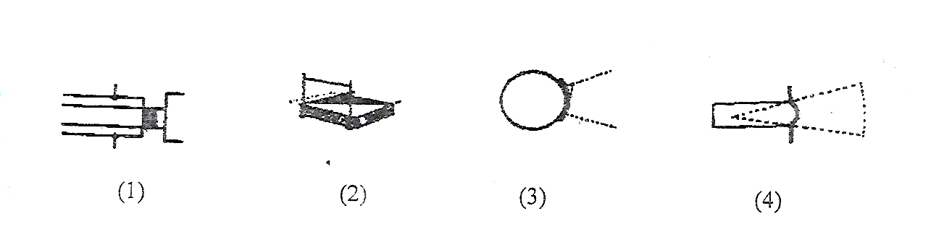**You have been appointed to direct the athletes to the relevant play areas in an Athlete Competition shown below.**

08. Which competitors will you be sending to the playground No 4?

i. Hammer throw ii. Javelin throw

iii. Shot put iv. Discus throw

09. The athletes who should send to the playground No 2 are,

i. Competitors taking part in high jump.

ii. Competitors taking part in pole vault

iii. Competitors taking part in high jump and pole vault.

iv. Competitors taking part in triple jump.

10. All events identified under athletics have been classified into,

i. 2 groups ii. 5 groups iii. 4 groups iv. 3 groups

11. The programs such as inter house sport meet and sports club in a school are,

i. Compulsory physical education programmes.

ii. Cocurricular physical education programmes.

iii. Physical education programmes of our school.

iv. Health promotion programmes of the school.

12. The rules are required in sports,

i. To make a fair play. ii. To avoid accidents.

iii. To protect the dignity of sport. iv. All of the above.

13. The total number of referees in a game of football is,

i. 1 ii. 4 iii. 3 iv. 2

14. A factor which does not affect in maintaining the balance at different body postures.

i. The centre of gravity. ii. Weight of an individual.

iii. Supporting base. iv. The line of gravity.

15. The number of players that can be registered in a volleyball team is,

i. 6 ii. 7 iii. 12 iv. 13

16. The duration of an interval between 2 rounds in a game of football is,

i. 15 min ii. 10 min iii. 7 min iv. 5 min

17. What is the correct formula for the momentum?

i. Momentum = $mass × mass$ ii. Momentum = $\frac{mass}{velocity}$

iii. Momentum = $mass × velocity$ iv. Momentum =

18. The number of players that play at a given time in a football game is,

i. 7 ii. 11 iii. 12 iv. 14

19. When seated, the centre of gravity is situated?

i. On the knees ii. On the hips

iii. At the end of the spine iv. On the belly button

20. How height from the ground, is the centre of gravity situated, on a person in standing position.

i. 60% ii. 72% iii. 56% iv. 48%

***(Marks 2 $×$ 10 $=$ 20)***

**Part II**

* **The first question is compulsory and select only 1 part from question No (02).**

01. i. Write 02 main types of postures and give examples for each. ***(02)***

ii. What are the 06 biomechanical principles that help to maintain posture? ***(05)***

iii. Define “Momentum” ***(03)***

iv. Describe the correct posture when using a computer. ***(03)***

v. What are the factors affecting the distance or the height of the jump of an athlete? ***(03)***

***(15 Marks)***

**Volleyball**

02. A). i. What are the 04 stages in blocking? ***(02)***

ii. Briefly explain what is meant by a player rotation offence. ***(03)***

iii. Write 02 penalties given for the rotation offence. ***(02)***

iv. Define “Spiking” in volleyball. ***(03)***

v. Describe with a diagram , an activity to practice blocking. ***(05)***

***(15 Marks)***

**Football**

B). i. What are the occasions where a kickoff is taken? ***(04)***

ii. Name the two main types of free kicks? ***(02)***

iii. Write 04 offences committed by players which results in awarding a direct free kick to the opponents. ***(04)***

iv. What are the factors that should be taken in to consideration when a throw-in is taken? ***(02)***

v. Write 03 duties of the main referee in football. ***(03)***

***(15 Marks)***